**Project Name:** Urban Sound Classification

**Project Team:** Niral Patel, Eunjeong Lee, Bill Pezzullo, Abby Pearson, Teshanee Williams

**Project** **information:**

Can we train a model to recognize urban sounds?

* Machine learning model to recognize the urban sounds. This will help identify urban sounds from sound file.

**ML Approach:**

* Clustering
  + Groups of sound dataset, Define the same sounds set of clusters size.
* Neural network
  + Normal learning
  + Deep learning with different number of hidden layers

**Tools to be used:**

* Python Pandas
* Python Matplotlib & Librosa
* Amazon AWS
* Database
* Jupyter Notebook

**Plan to present/display:**

* Present the educational information to provide background on sound data and sampling
* Present the Jupyter notebook to show developing JSON file from sound file.
* Display Jupyter notebook, to show training of ML model
* Display the working urban sound classification model

**Project Timeline:**

|  |  |
| --- | --- |
| **High-level Tasks** | **Due Date** |
| Obtain & Understand data required | 11/03 |
| Develop and train the ML model | 11/05 |
| Test and adjust ML model for desire output | 11/07 |
| Develop presentation schema | 11/10 |
| Final practice for presentation | 11/12 |

**High Level Flow:**

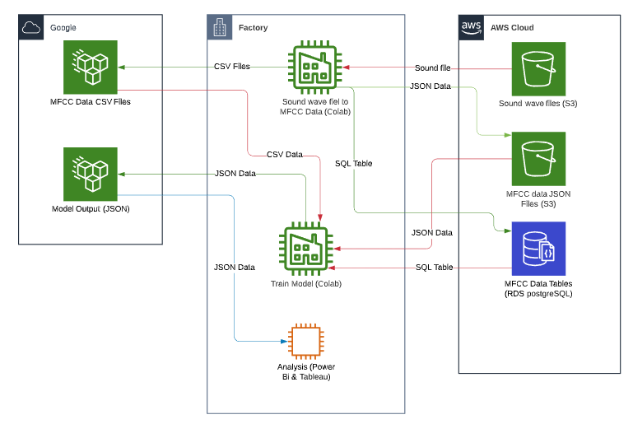

**Link to dataset/information:**

[**https://urbansounddataset.weebly.com/urbansound8k.html**](https://urbansounddataset.weebly.com/urbansound8k.html)

<http://www.justinsalamon.com/uploads/4/3/9/4/4394963/salamon_urbansound_acmmm14.pdf>

<https://towardsdatascience.com/urban-sound-classification-part-1-99137c6335f9>